

**LA GRANDEE International College  
Simalchour, Pokhara, Nepal**

PO Box: 42 || Tel: 977-61-523163/532844 || Fax: 977-61-539304

Email: info@lagrandee.edu.np

www.lagrandee.edu.np

A Project report

on

La Grandee Departmental Stores

**Submitted to**

LA GRANDEE International College

Bachelor of Computer Application(BCA) Program

In partial fulfillment of the requirement for the bachelor degree of BCA under

Pokhara University

**Submitted by :**

**Name Exam Roll no:**

**Bimal Khadka 13050097**

**Binaya Gurung 13050098**

**Mukta Gurung 13050113**

**Shankar Pun 13050129**

**Date:-December 29, 2013**

**Declaration for**

**“ La Grandee Departmental Stores“**

**Student’s Declaration**

We hereby declare that we are the only authors of this project and that no sources other than the listed here have been used in this project.

Name of the Students Class Roll No:

**Bimal Khadka ………………….**

**Binaya Gurung ………………….**

**Mukta Gurung ………………….**

**Shankar Pun ………………….**

BCA,2nd Semester

Date: 2013/12/29  **Supervisor’s declaration**

I hereby recommend that this project entitled “**La Grandee Departmental Stores**” is done under my supervision by **Binaya Gurung, Bimal Khadka, Mukta Gurung, Shankar Pun** during their 2nd Semester in partial fulfillment of the requirement for the degree of **BCA** under **Pokhara University** is completed to my satisfaction and be processed for final evaluation.

Name of the supervisor

Date: 2013/12/29

**Letter of Approval**

We certify that we have examined this report entitled “**La Grandee Departmental Stores**”, and are satisfied with the project defense. In our opinion it is satisfactory in the scope and qualifies as project in partial fulfillment of the requirements for the degree of **BCA** under **Pokhara University.**

**Supervisor Examiner Program Coordinator**

**Date: 2013/12/29**

**ABSTRACT**

We have entitled the software system as “**La Grandee Departmental Stores**”. The software prepares a tax invoice for a customer as well as keeps track of inventory in the stock. It prompts user a message incase if any of the item is running out in the store. The software also provides details of every item in the store with its code, name, number in stock and price. It also allows adding any new items added in the store. It also provides another facility to search any item in the list along with its details. It fulfills most of the preliminary work in a departmental store which was done manually previously.

We have prepared this software in a basic C language, which itself lacks many features. So, there are some limitations that we have realized while developing this software which mainly include: unable to use a POS to provide input (input is provided manually through keyboard in this software), unable to produce printed output (tax invoice) and also it is not user friendly as it should as it should have been. It also lacks financial accounting module. We intend to eliminate all these limitations of the software, if we are able to work on the same project in the future.

**Table of content:**

1. **Introduction ……………………..………………………....1**
2. **Problem Statement……………..…………………………....2**
3. **Objectives…………………………………………..………...3**
4. **Requirements documents…………………………………....4**
5. **System design………………………………………………...5**
6. **Development…………………………………………………6-12**
7. **Testing………………………………………………………...13**
8. **Project result…………………………………………………14-16**
9. **Future Enhancement………………………………...………17**
10. **Conclusion…………………………………...……………….18**
11. **Reference…………………………...………………………...19**
12. **Annex........................................................................................20**

**1. INTRODUCTION**

In general term, project means a carefully planned piece of work that has a particular purpose in practical field. In order to meet the definition of the project, we have chosen the topic on “the billing system of departmental store”. A departmental store is a retail establishment which specializes in satisfying a wide range of durable goods and products to the consumer personal and residential needs and at the same time offering the consumer a choice of multiple goods lines, at variable price.

At the present moment, there are many businesslike: shopping business trading business, service business, etc. in the global world. They are small business to large business. On the behalf of us, we select this project in order to make the departmental store transaction easy and faster than the past year. Similarly, to make our project meaningful, our team members have put equal contribution on researching and collecting materials for the project. So we think that our project will help all the departmental stores members efficient while recording the various products.

**2. Problem Specification**

There are some limitations that we have realized while developing this software which are listed below:

1. In reality, a POS (Point of Sell) detects the item code and it automatically feeds it in the computer as input. But, in this software, we lack the feature of POS, so we need to give item code through keyboard manually.
2. This software lacks the feature of being user friendly as no graphics is used.
3. This software cannot produce the hardcopy output (tax invoice).
4. The software lacks financial accounting module.

**3. Objectives**

While going through the different Departmental Stores of the city, we found most of them are using manual billing system. This will give rise to lots of mistakes. Traditional methods should be replaced by newly improved billing system. Therefore, our software will help them to work efficiently.

The following are the main objectives of our project work:

* To make Departmental stores systematic.
* To introduce a new technology in Departmental Stores.
* To manage the time and work efficiently.**4. Requirements Documents**

We have programmed this project using ‘C Free’ which requires following requirements:

Operating System: Windows based server.

Hard-disk: At least 5 MB free.

Processor:200 MHz or higher.

RAM:At least 256 MB

**5. System design**

The development of the program we are going to manager is in the waterfall model. The management plan on project is shown below:

Requirement and Analysis

Design

Testing and Debugging

Coding

Implementation

Fig: 1.1 - waterfall model

**6. Development**

|  |
| --- |
| #include <stdio.h>  #include <conio.h>  #include <string.h>  #include <time.h>  #include <windows.h>  struct Store  {  char g[50],m,e;  int q;  float r,d;  float amount;  float tax;}s;  int c;  static char mo,pa,g[50];  static int qq;  int distim();  int datess();  int timess();  int copy();  void office();  void customer();  void help();  void about();  void search();  void showall();  void add();  void remov();  void edit();  void ex();  main()  {  system("color 0a");  system("welcome.wma");  char x;  sec:  while(1)  {  system("cls");  distime();  printf("\t\t###############################################\n\t\t##\tLA Grandee Departmental Store\t ##\t\t\n\t\t##\t-----------------------------\t ##\n\t\t##\tSrijana Chowk, Pokhara, Nepal\t ##\n\t\t##\t\t\t\t\t ##\n\t\t##\t Ph no: 061-123456\t\t ##\n\t\t##\t\t\t\t\t ##\n\t\t###############################################");  printf("\n\n\n\t ");  printf("\t1.OFFICE USE\t\t\t2.CUSTOMER USE\n\n\t\t3.HELP\t\t\t\t4.ABOUT\n\n\t\t\t\t5.EXIT\n\n");  printf("\tCHOOSE THE ABOVE OPTION TO OBTAIN A TASK:-\t");  x=getche();  x=toupper(x);  system("cls");  switch(x)  {  case '1':  printf("\n\t\tYou have selected for OFFICE USE:-");  office();  break;  case '2':  printf("\n\t\tYou have Seleced for CUSTOMER USE\n\n\n\t");  customer();  break;  case '3':  printf("\n\t\t\tHELP:");  help();  break;  case '4':  printf("\n\t\t\tABOUT US:-\n\n ");  about();  break;  case '5':  ex();  break;  case 'S':  system("systeminfo");  printf("\n\t\t\tPress any key to continue");  break;  case 'B':  system("bill.txt");  printf("\n\n\n\n\t\t\tPress Any key to continue");  break;  case 'C':  printf("\n\n\n\t\t\tCOLOR changed Applied");  system("color 1a");  break;  default:  system("cls");  system("incorrect.wma");  printf("\aIncorrect Input");  printf("\nAny key to continue");  }  binaya:  getch();  }  }  void office()  {  char choice;  while (1)  {  system("cls");  printf("\n");  printf("\n\t 1. ADD NEW ITEMS.\t \t2. SHOW ALL ITEMS");  printf("\n\n\t 3. EDIT ITEMS.");  printf("\t\t \t4. SEARCH ITEMS.");  printf("\n\n\t 5. REMOVE ITEMS.\t\t6. BACK TO MAIN MENU\n");  printf("\n");  printf("\n\n\t CHOOSE THE OPTION:-" );  choice=getche();  choice=toupper(choice);  switch(choice)  {  case '1' :  add();break;  case '2' :  showall();break;  case '3':  edit();break;  case '4' :  search();break;  case '5':  remov();break;  case '6':  system("cls");  main();  break;  default:  system("cls");  printf("\a Incorrect Input");  system("incorrect.wma");  printf("\n Any key to continue");  getch();  }  }  }  void customer()  {  remove("Bill");  float amount,net,total=0;  int n,i;  float a,b;  FILE *f;  FILE *cus;  time_t m;  m=time(NULL);  cus=fopen("Bill.txt","w");  fprintf(cus,"\t\t\t LA Grandee Departmental Store\n\t\t ------------------------------------------\n\t\t\t Srijana chowk, Pokhara, Nepal.\n\t\t\t Phone no: 061-123456\n");  fprintf(cus,"\n\n\n\n\t\t\t\t\t BILL");  fprintf(cus,"\n");  fprintf(cus,"\n\t\t\t DATE & TIME : ");  fprintf(cus,(ctime(&m)));  fprintf(cus,"\n\nBilling Mode : General");  fprintf(cus,"\t\t\t\t\t\t\t Billing Mode : Cash\n");  printf("\n\n\n\n\n\n\n\tHow many types of Items are bought by the customer: ");  scanf("%d", &n);  for(i=1;i<=86;i++)  {fprintf(cus,"-");}  fprintf(cus,"\n");  for(i=1;i<=86;i++)  {fprintf(cus,"-");}  fprintf(cus,"\n");  fprintf(cus,"\n\nItems\t\t | Rate\t | Quantity\t | Amount\t\n");  for(i=0;i<86;i++)  fprintf(cus,"-");  for(i=1;i<=n;i++)  {  int flag=1;  f=fopen("data.dat","rb+");  if(f==0)  exit(0);  fflush(stdin);  system("cls");  printf("\n\n\n\n\n\n\n\t\tEnter the name of the item: ");  scanf("%s", g);  strlwr(g);  while(fread(&s,sizeof(s),1,f)==1)  {  if(strcmp(s.g,g)==0)  { system("cls");  flag=0;  break;  }  else if(flag==1)  { system("cls");  }  }  system("cls");  printf("\n\n\n\n\n\n\n\t\tEnter the Quantity of %s: ",g);  scanf("%d", &qq);  amount=s.r*qq;  a=amount*s.tax/100;  b=amount*s.d/100;  net=amount+a-b;  fprintf(cus,"\n%s\t\t %0.2f\t %d\t %0.2f\t\n",s.g,s.r,qq,amount);  fprintf(cus," \t\t \t \t TAX = %0.2f \t\n",a);  fprintf(cus," \t\t \t \t DISCOUNT = %0.2f \t\n",b);  fprintf(cus," \t\t \t \t NET = %0.2f \t\n",net);  total=total+net;  }  for(i=0;i<86;i++)  fprintf(cus,"-");  fprintf(cus,"\n \t\t \t \t Total = %0.2f \t\n",total);  fprintf(cus,"\n\n\t Broken and expired Goods will not be returned.\n");  fclose(f);  system("cls");  fclose(cus); |

**. Testing**

**7.1 Logical testing**

This will be used to test every aspect of each form, as soon as it is implemented, using valid, invalid and extreme data. Test data will be added to test each code module and results compared with the expected results.

**7.2 Functional testing**

Each menu item will be tested in turn to ensure that no function has been missed out.

**7.3 System testing**

When the system is completed, the whole range of tests will be carried out again to ensure that no errors have been introduced.

**7.4 Acceptance Testing**

The user will then be involved and asked to test all the capabilities of the program to ensure that all required functions are present and working in the manner expected. This testing may result in further refinements.

**8. Project result**

After installing and launching our program.

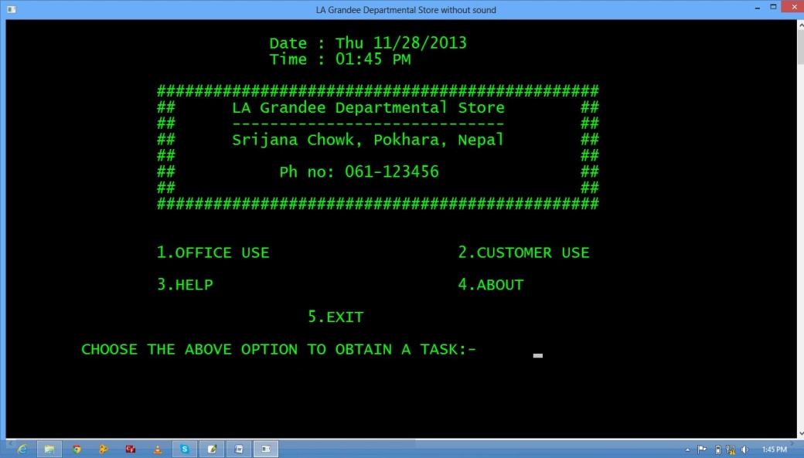

Fig 1.2 – main screen

After choosing Office use.

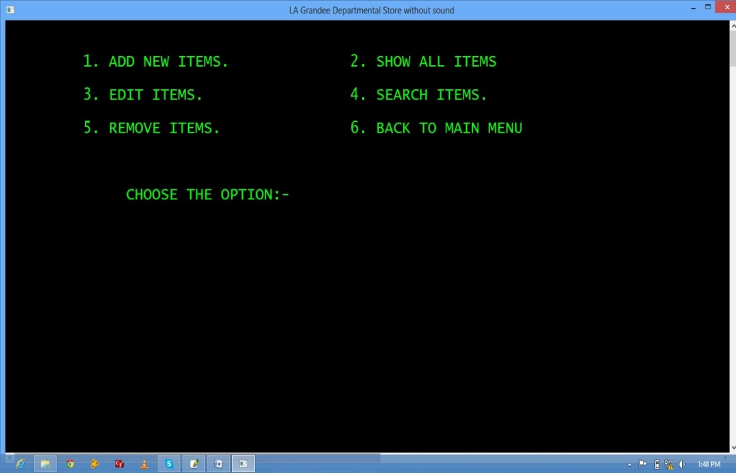

Fig 1.3 – office use Users can easily add, edit, search, & remove the data using office use option.

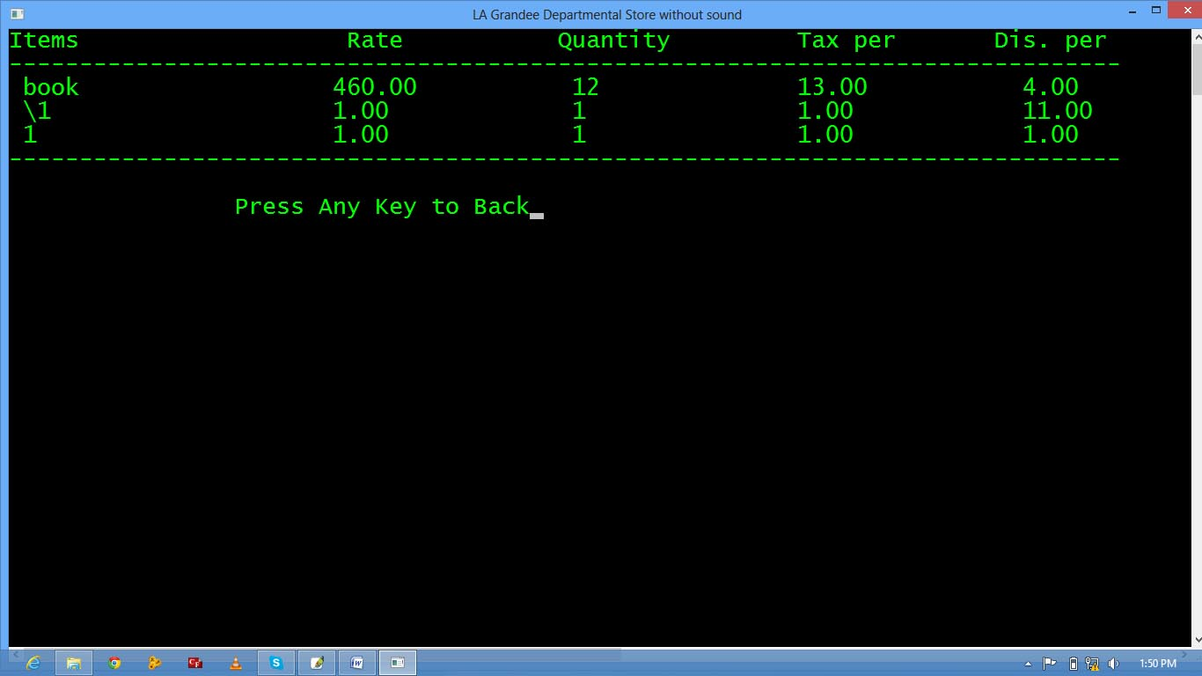

Fig 1.4 – show all

If the users choose for customer use,

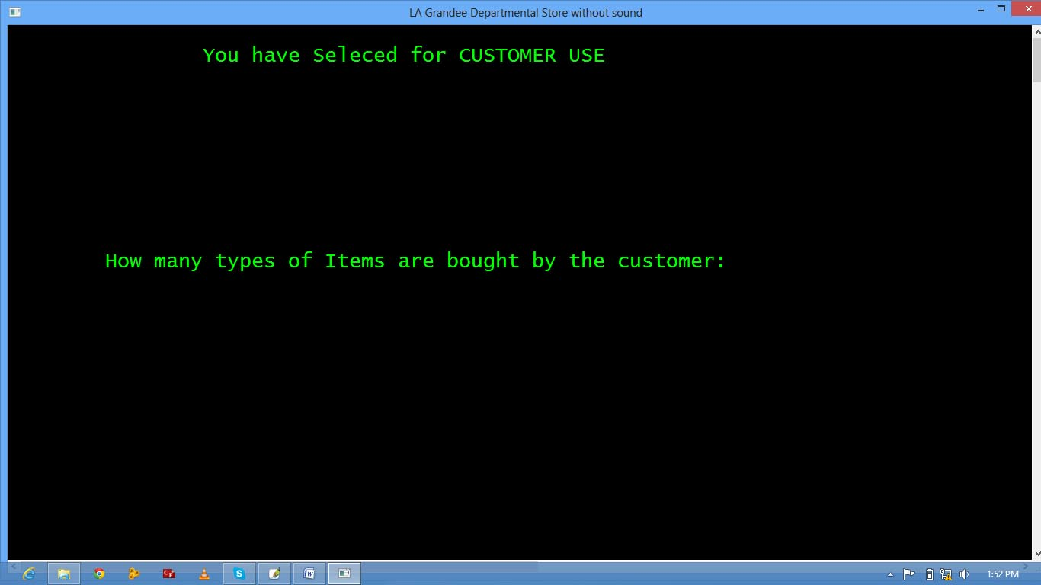

Fig 1.5 – customer use

After entering required items and quantity.

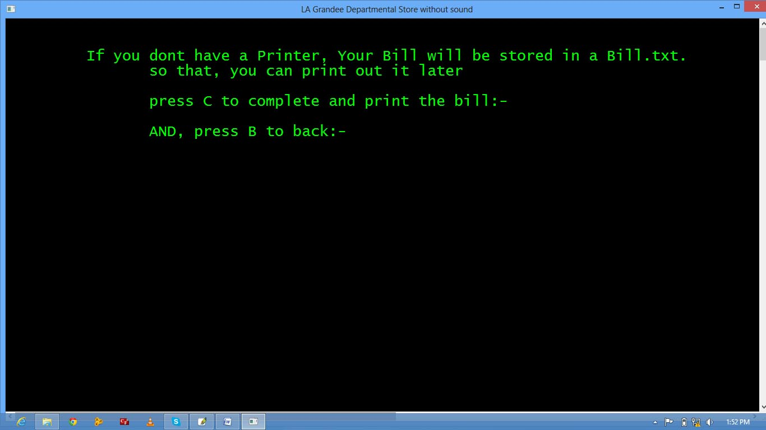

Fig 1.6 – Print function

Users can easily print the bill by pressing “c”.

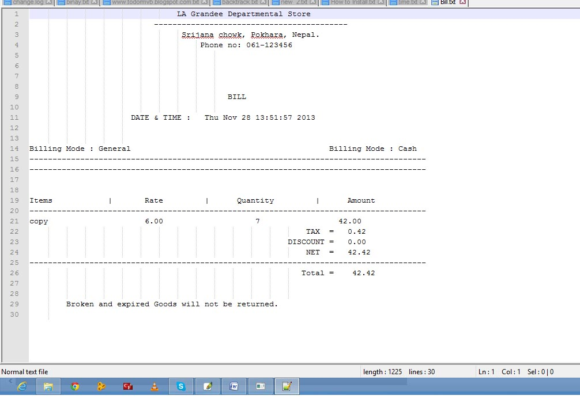

Fig 1.7 – outlook of bill

**9. Future Enhancement**

This project has been prepared as a supplement to a bachelor level course. It of course has several limitations and shortcomings. But we hope it can be used in every field that deals with buying and selling activities. **10. Conclusion**

We have prepared the following mentioned software as a part for fulfillment of requirements for the degree of Bachelor of Computer Application under Pokhara University. We have written the software in C language because it was the only programming language taught during the year. The software is a result of months of hard work by our project members. It fulfills most of the preliminary work in a departmental store which was done manually previously. It can produce a tax invoice, manager the stock account, search and add any items in the stock. Because it is our first project as a part of study course, we couldn’t add many other features. These limitations are because of both our lack of knowledge and limitation of C language. These limitations mainly are: unable to use a POS to provide input (input is provided manually through keyboard in this software), unable to produce printed output (tax invoice) and also it is not user friendly as it should have been. We intend to eliminate all these limitations of the software, if we are able to work on the same project in the future. We would like to recommend this software to La Grandee because it is faster than any worker in the complex, it can replace about five workers from the complex, thus saving its salary expenses, time, effort, and it performs its task with 100% accuracy.

**11. Reference**

let us c by yashavant kanetkar

Learning by examples.

**12.Annex**

Cook David, (2012). C programming for websites. USA: Times Press

**Retrived from:**

<http://www.united.com/programming.html>

<http://www.wikipedia.com/c-programming.html>